BIRD063 Newsletter 30

* 031 – 262 1630

www.wendonacademy.co.za

27th September 2016

Dear Parents and Pupils,

We are officially at the end of our 3rd term. We have been “Busy Bees” with the “Rhythm is Gonna get You”, Work Experience, the Beautiful Wendon Ball, the various outings and the Cultural Dress up day!

**CULTURAL DRESS - CELEBRATING OUR HERITAGE**

Thank you to the children who participated in celebrating their cultural dress, they were outstanding!

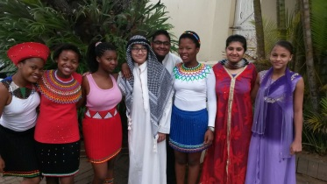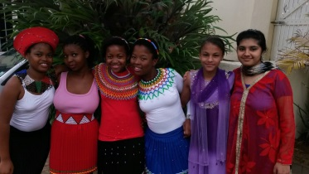

**Our Senior Primary were Splendid!**

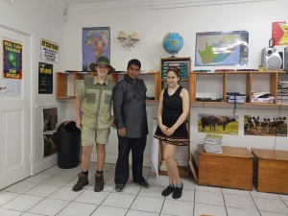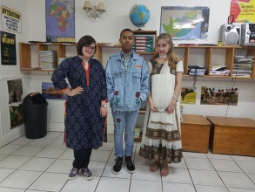

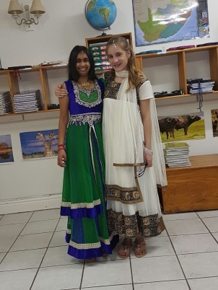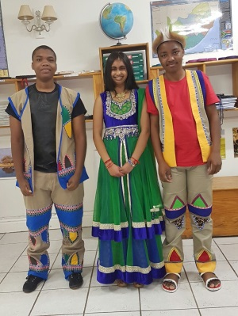

**Our High School were Awesome!**

**WHAT’S ON FOR BREAK UP DAY! – 28th SEPTEMBER**

1. The High School will be playing **soccer** against Damorosa School from 10h30 – 12h00. Pupils to come to school in their normal summer uniform and will change into their sponsored soccer kit at school.

2. The Senior Primary will have **fun time** with activities in the hall.

3. **Reports** will be handed out, so please check your child’s school bag.

4. School will **close** as per normal 13h20 Senior Primary and 13h30 High School.

**ART EXTRAVAGANZA & PICNIC UNDER THE STARS – 21st OCTOBER**

Join us in celebrating you child’s magnificent, creative **ART & PRACTICAL items** displayed in the hall.

**Bring your own** PICNIC BASKET & relax with family & friends, enjoying the entertainment with Mr Didlick. Fires provided if you want to braai. Please complete your reply slip below. NB: This is a compulsory event for Wendon Academy pupils. Invitations were sent out last week 20th Sept

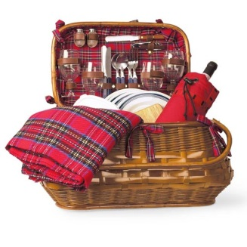



Waltons Stationery List for 2017, were handed out yesterday 26th September so please be sure to check your child’s school bag.

Please take note of dates and deadlines should you want to order from Waltons. Send your orders back to Wendon as soon as possible. The stationery will then be delivered to school in November, alleviating those dreadful queues when buying stationery for 2017.

Last order date is **Tuesday 8th November.**

Invoices will be sent on **Monday 14th November**

Collection of stationery is on **Monday 21st November.**

Please do not order any stationery that your child already has and can use again next year. Stationery will only be released once payment has been received.

Please **DO NOT** send in **CASH**, we ask that you do an **EFT into WALTONS account** (not Wendon Academy).

An invoice will be sent to school prior to the delivery of stationery. This will then be sent to you as soon as possible. You will be given the banking details and a reference number to record as proof of payment. PLEASE send in proof of payment to Wendon Academy on email [admin@wendon.co.za](mailto:admin@wendon.co.za).

**(PLEASE NOTE: NO CHEQUES WILL BE ACCEPTED)**



**No orders** will be accepted at Wendon **later than Tuesday 8th November** as Waltons will do the final collection on this day.



A simple way to raise funds for the school without costing us a cent – Its MONEY for JAM!!!. We will forward an application form to each parent next week, in the hopes of securing support in this fundraising endeavour.

***CALENDAR OF EVENTS***

***September***

|  |  |  |
| --- | --- | --- |
| Tues 27th Sept | Senior Primary Open Day  Waltons Catalogue Distributed | 13h00 – 14h00 in classrooms  Waltons 2017 Orders |
| Wed 28th Sept | High School -Soccer Day  Senior Primary Fun Day  School Closes 13h30 | Reports will be handed out |

**October**

|  |  |  |
| --- | --- | --- |
| Tuesday 11th Oct | Start of Term 4 |  |
| Friday 21st Oct | Art Extravaganza & Picnic under the Stars | Invitations were sent on 20th Sept - R20/Adult & R10/Child |
| Friday 28th Oct | Matric Farewell Breakfast  Final Walk | Invitations will be sent out early next term |
| Monday 31st Oct | Study Leave Gr8-12 |  |

**November**

|  |  |  |
| --- | --- | --- |
| Tuesday 1st Nov | Study Leave Gr8-12 |  |
| Wednesday 2nd Nov – Friday 11th Nov | Tests and Exams |  |
| Tuesday 8th Nov | Waltons Stationery 2017 | Final day to submit Waltons Orders |
| Monday 21st Nov | Waltons Stationery | Boxes of Stationery to take home |
| Tuesday 22nd | Gr7 Fun day |  |
| Friday 25th Nov | End of year Braai | Bring braai packs and costumes |
| Tuesday 29th Nov | High School Prize Giving | 18h30 |
| Wednesday 30th Nov | Senior Primary Prize Giving | 18h30 |

**December**

|  |  |  |
| --- | --- | --- |
| Thursday 1st Dec | School Closes for 2016 at 11h00 |  |

**\*\*\*\*\*This Calendar of Events may change from time to time, so please be sure to check it out each week for any updates or amendments\*\*\*\*\***

**Flowers in the Foyer –4th Term**



|  |  |
| --- | --- |
| **Term 4** | |
| 11th Oct | McKenzie Family - Luke – Gr 12 |
| 17th Oct | Magudulela Family - Sabelo – Gr 10 |
| 24th Oct | Marsland Family - Tara – Gr 10 |
| 14th Nov | Mbambo Family - Minnie – Gr 10 |
| 22nd Nov | Aboobaker Family - Mohamed – Gr 10 |
| Prize Giving | Christodoulou Family – Aik Gr 12 |

We will continue with the Change for Charity and Bread Tags for our Outreach Programme this term:

|  |  |
| --- | --- |
| **Change For Charity** | **Bread Tags for Wheelchairs** |
| This ongoing collection of “**small change**” will benefit our fundraising project. Please “raid” your purses and get rid of any unwanted change. | Please collect the small plastic **bread bag tags** and send these to school. Approximately 200kg of bread tags buys a wheel chair for a disabled person. |

We wish you all a safe and enjoyable short holiday. **School commences on Tuesday 11th October**. We certainly look forward to welcoming all our children back for our final term of the year.

Kind regards

Mrs Wendy Hicks

Managing Director

***“The greatest gift that you can give to others is the gift of unconditional love and acceptance.” – Brian Tracy***

✂ - - - - - - - - - - - - -

**Art Extravaganza – Picnic Under the Stars!**

Friday, 21st October 2016, 18h00

Name: _____________________________________ Grade: __________

**RSVP** by Monday, 17th October

I will be attending the “Bring your own Picnic Basket Art Extravaganza: YES/NO

**NB:** This is a compulsory event for Wendon Academy pupils – n/c.

Number of Adults attending @ R20 each: __________________________

Number of Children attending @ R10 each: __________________________

Total Amount enclosed: R_____________