BIRD063 Newsletter 33

* 031 – 262 1630

www.wendonacademy.co.za

25th October 2016

Dear Parents and Pupils,

**ART EXTRAVAGANZA EVENING – PICNIC UNDER THE STARS!**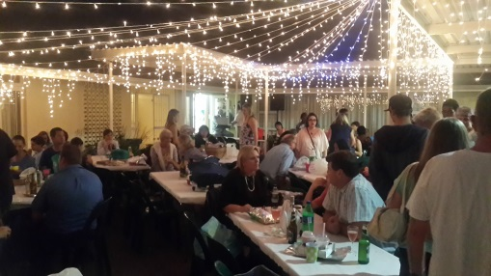

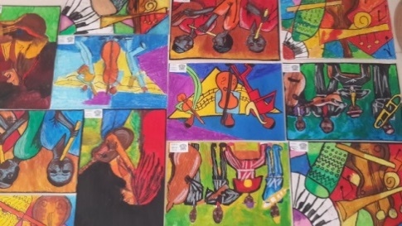What a wonderful evening we had at the Art Extravaganza on Friday evening. I think I can speak for everyone that came when I say that the Art and Creative content displayed, was phenomenal! The standard was exceptional and we had so many parents who were so excited to see their children’s work displayed. Our children were so excited and worked tirelessly to put everything together to showcase their achievements. What a proud moment for them and certainly for us. Thank you again for attending the evening and making it a huge success.



**MATRIC FAREWELL BREAKFAST & FINAL WALK OUT OF WENDON ACADEMY**

It is with mixed emotions that we come to this moment in our Grade 12’s lives where they have their final walk out of the school.

They will join us on Friday with their parents at a farewell breakfast. This is followed by the final walk past all the Wendon children and Teachers for the year 2016.

**STUDY LEAVE FOR GRADES 8-12**

With all this behind us, heads need to be into books to study for this year’s final examination. We know that you will give of your very best. We wish our pupils happy studying at this time.

Last order submission: **Tuesday 8th November.**

Invoices will be sent on: **Monday 14th November**

Collection of stationery is on **Monday 21st November.**

Please do not order any stationery that your child already has and can use again next year. Stationery will only be released once payment has been received.



**No orders** will be accepted at Wendon **later than Tuesday, 8th November** as Waltons will do the ***final collection on this day***.

**Our School Caretakers – Favourite and Clarance**

Please can we all remember our dedicated caretakers who constantly maintain cleanliness within our school property. What would we do without them? Let us show our gratitude by sending in the following consumables by Grade **or a cash donation would be greatly appreciated**. This needs to be in by the 18th November.

Thank you to those who have sent in already, it is much appreciated.

|  |  |  |  |  |  |  |  |
| --- | --- | --- | --- | --- | --- | --- | --- |
| **JUNIORS** | **GRADE 6** | **GRADE 7** | **GRADE 8** | **GRADE 9** | **GRADE 10** | **GRADE 11** | **GRADE 12** |
| Mealie Meal  Sweets  Biscuits  Hand soap  Hand cream  Sugar Beans  Rice  Bully Beef  Dishwashing  Liquid | Washing Powder  Coffee  Sweets  Baked Beans  Oil  Flour  Salt  Tuna Tins  Face Cloth | Sugar  Biscuits  Jam  Tinned Veg  Tinned Fruit  Tea  Peanut Butter  Soya Mince  Salt + Pepper | Rice  Mealie Meal  Sugar Beans  Sugar  Oil  Tea  Biscuits  Oats  Coffee | Long life Milk  Biscuits  Sweets  Oil  Rice  Instant Pud  Rusks  Samp  Salt +  Pepper | Bath Soap  Face Cloths  Tinned Veg  Tinned Fruit  Rice  Mealie Meal  Washing powder  Salt  Beans | Rice  Mealie Meal  Sugar Beans  Sugar  Oil  Tea  Biscuits  Chocolate  Coffee | Mealie Meal  Sweets  Biscuits  Hand soap  Toothpaste  Sugar Beans  Rice  Tuna Tins |
| MANY MANY THANKS!! | | | | | | | |



**Flowers in the Foyer –4th Term**

|  |  |
| --- | --- |
| **Term 4** | |
| 24th Oct | Marsland Family - Tara – Gr 10 |
| 14th Nov | Mbambo Family - Minnie – Gr 10 |
| 22nd Nov | Aboobaker Family - Mohamed – Gr 10 |
| Prize Giving | Christodoulou Family – Aik Gr 12 |

***CALENDAR OF EVENTS***

**October**

|  |  |  |
| --- | --- | --- |
| Friday 28th Oct | Matric Farewell Breakfast  Final Walk | 08h00 – 10h15 |
| Monday 31st Oct | Study Leave Gr8-12 |  |

**November**

|  |  |  |
| --- | --- | --- |
| Tuesday 1st Nov | Study Leave Gr8-12 |  |
| Wednesday 2nd Nov – Friday 11th Nov | Test and Exams | All tests and examinations start promptly at 08h00 |
| Tuesday 8th Nov | Waltons Stationery 2017 | **Final day to submit Waltons Orders** |
| Monday 21st Nov | Waltons Stationery 2017 | Waltons Stationery to take home, if paid |
| Tuesday 22nd | Gr7 Fun day | Details to follow |
| Friday 25th Nov | End of year Braai | Bring braai packs and costumes |
| Tuesday 29th Nov | High School Prize Giving | 18h30 |
| Wednesday 30th Nov | Senior Primary Prize Giving | 18h30 |

**December**

|  |  |  |
| --- | --- | --- |
| Thursday 1st Dec | School Closes for 2016 at 10h45 | Reports will be handed out |

**\*\*\*\*\*This Calendar of Events may change from time to time, so please be sure to check it out each week for any updates or amendments\*\*\*\*\***

**“Imagination is the highest kite that one can fly” – Lauren Bacall**

Kind regards

Mrs Wendy Hicks

Managing Director

**Grade 9-12 Exam Time Table – Oct / November 2016**

|  |  |  |
| --- | --- | --- |
| **Computer Exams** | | |
| **Date** | **Grade** | **Time** |
| Monday 24th October | Grade 9 | 08h00 – 10h00 |
|  |  |  |
| Wednesday 26th October | Grade 10 | 08h00 – 10h00 |
|  |  |  |
| Thursday 27th October | Grade 11 | 08h00 – 10h00 |

|  |  |  |  |
| --- | --- | --- | --- |
| **Date** | **Subject and Grade** | **Time** | **Teacher on Duty** |
| Monday 31st Oct | Study Leave Grade 9, 10, 11 and 12 | | |
|  | | | |
| Tuesday 1st Nov | Study Leave Grade 8, 9, 10, 11 and 12 | | |
|  | | | |
| Wednesday 2nd Nov | T&T  Gr 9 – Gr 12 | 08h00 – 09h30 | Mrs Gooding  Mrs Freeman |
|  | | | |
| Thursday 3rd Nov | English  Gr 9 – Gr 12 | 08h00 – 10h00 | Mr Didlick  Mrs Hattingh |
|  |  |  |  |
| Friday 4th Nov | Maths  Gr 9 – Gr 12 | 08h00 – 09h30 | Mrs Freeman  Mrs Gooding |
|  |  |  |  |
| Monday 7th Nov | EMS  Gr 9 – Gr 12 | 08h00 – 09h30 | Mrs Hattingh  Mr Didlick |
|  |  |  |  |
| Tuesday 8th Nov | Cookery  Gr 9 – Gr 10  Computers  Gr12 | 08h00 – 09h30  8h00 – 10h00 | Mrs Gooding  Mrs Perold |
|  |  |  |  |
| Wednesday 9th Nov | Study Leave Grade 8, 9, 10, 11 and 12 | | |
|  |  |  |  |
| Thursday 10th Nov | English Paper 2  Gr 9 – Gr 12 | 08h00 – 09h30 | Mr Didlick  Mrs Hattingh |
|  |  |  |  |
| Friday 11th Nov | Maths Paper 2  Gr 9 – Gr 12 | 08h00 – 09h30 | Mrs Freeman  Mrs Perold |

Full academic classes to resume on Monday 14th November for Grade 8 to Grade 11.

**GRADE 8 – EXAM TIMETABLE FOR OCTOBER / NOVEMBER 2016**

|  |  |  |
| --- | --- | --- |
| Tuesday 25th Oct | Computer | 8.00 – 10.00 |
| Monday 31st Oct | STUDY LEAVE |  |
| Tuesday 1st Nov | STUDY LEAVE |  |
| Wednesday 2nd Nov | SS | 8.00 – 9.30 |
| Thursday 3rd Nov | English | 8.00 – 10.00 |
| Friday 4th Nov | Maths Literacy | 8.00 – 9.30 |
| Monday 7th Nov | EMS | 8.00 – 9.30 |
| Tuesday 8th Nov | Cookery | 8.00 – 9.30 |
| Wednesday 9th Nov | STUDY LEAVE |  |
| Thursday 10th Nov | English 2  NS | 8.00 – 9.30  10.00 – 11.30 |
| Friday 11th Nov | Maths 2 | 8.00 – 9.30 |